Use case Diagrams

Draw for actor - Customer

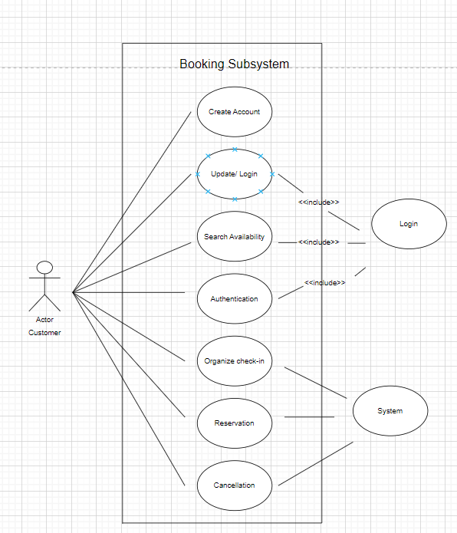

<<includes>> Relationship

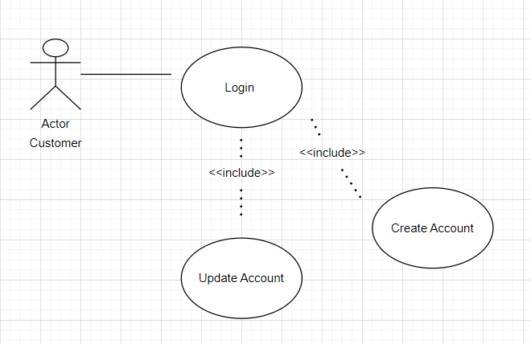

<<exclude>> Relationship

